Spell Invaders

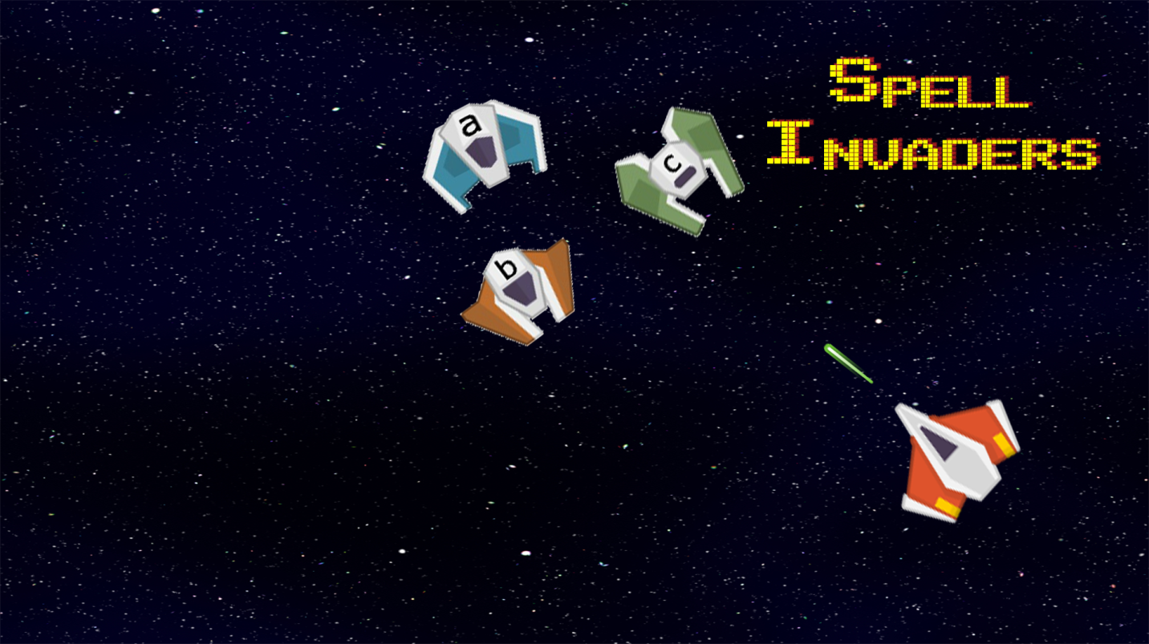

Table of contents

Page 1 – Introduction/main menu

Page 2 – options menu

Page 3 – game level

Page 4 – how to play

Introduction

Spell invaders is a 2d space shooter game made in the unity engine. Its goal is designed to teach both children and adults the spelling of different words that sound similar to one another also known as homonyms.

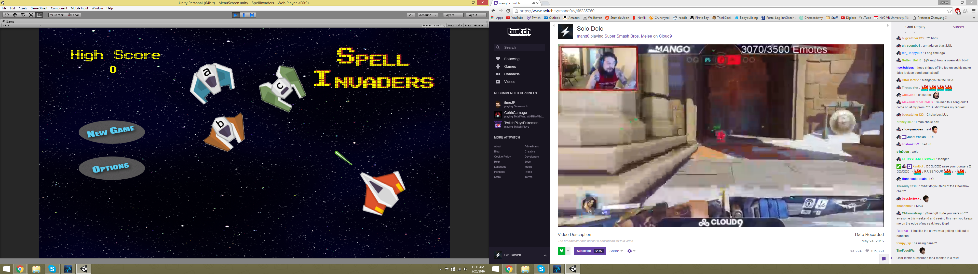

Main menu

The top left displays the players high score which they accumulate through shooting the correct enemies that spell the word for that level.

New Game starts the game with a random word for the user to spell

Options Menu allows small customizations to the game

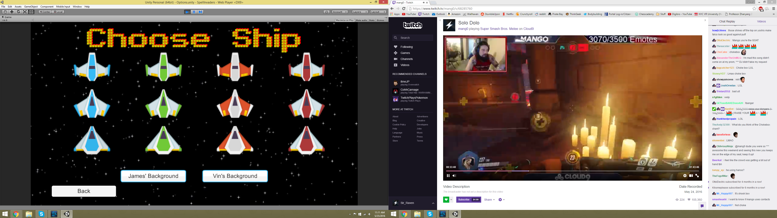

Options menu

In the options menu, accessible through the main menu, the player can choose one of twelve different ships to be displayed in the game. Each ship preforms the same and does not affect gameplay. The two buttons at the bottom change the background in the main levels of the game. James’ background is a simpler design while vin’s is more like classic arcade shooters. Try both and see which you prefer!!

Click the back button while take you back to the main menu when you are done.

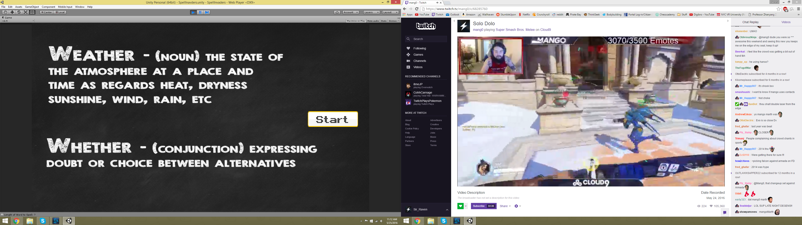

Game level

When starting a new game you begin with a list of possible words that you must spell with their definition to discern the difference between the homonyms.

Clicking start will start the game and put the player in control.

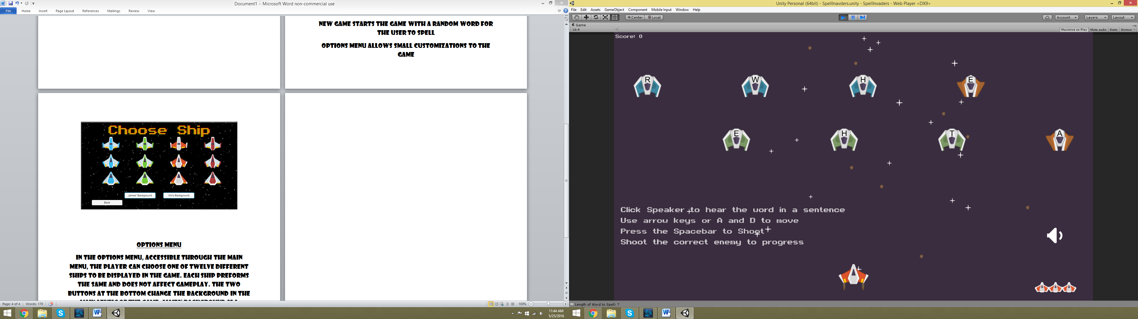

In the actual game the player is displayed a the bottom and enemies that the player must shoot to spell at the top

The players lives are displayed at the bottom right and their score at the top left. Be careful, enemies shoot back!!

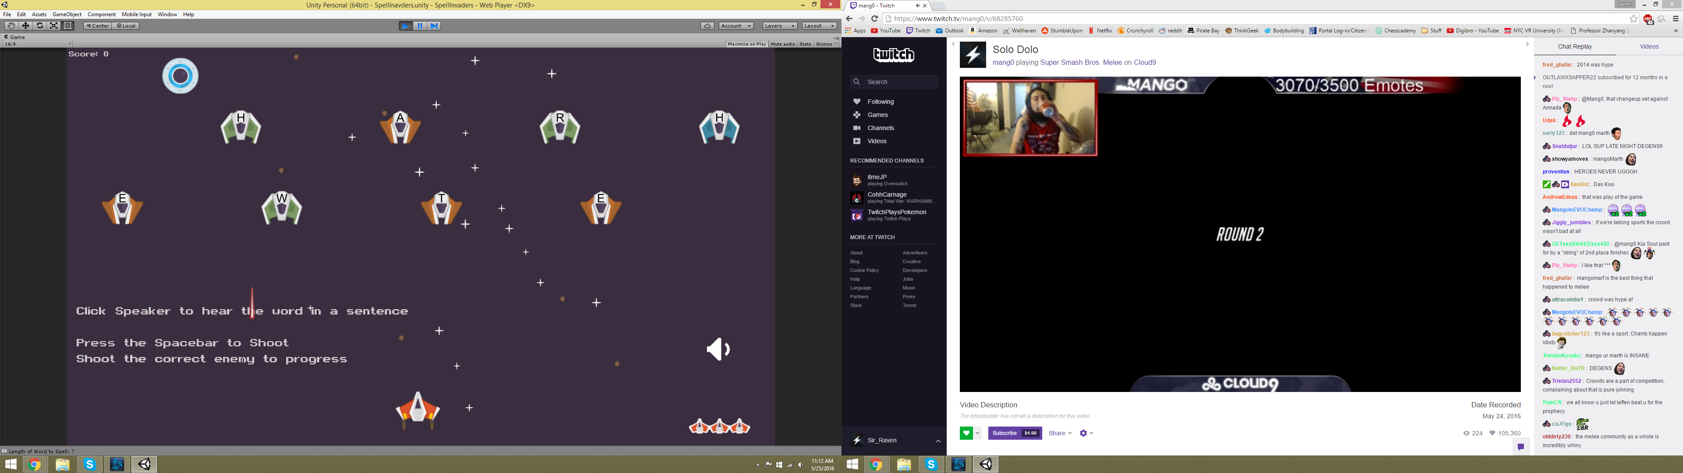

How to play

* Use the arrow keys or a and d to move the player left and right
* Press the spacebar to shoot a laser at the enemies
* Click the speaker icon at the right replays the sentence. Using the sentence, decide which of the words displayed at the beginning needs to be spelled
* Then you must shoot the enemies in the correct order to spell the word but be careful the enemies will shoot back.
* Shooting the ufo that appears at the top will give the player a power up:
* - gives the player a shield to protect themselves from one laser.
* Shooting all the correct enemies will complete the level and progress the player to the next level with a new random word
* Try to get the best score before a game over. Good luck!!